Engineering Application Software quiz 2 Class: 電通三乙 Name:李易軒 Student ID:05050084

- (a) Write a function that attempts to locate the maximum and minimum values of an arbitrary function f(x) over a certain range.

The function should have the following input arguments:

first_value = the start of the interval to search(搜尋的區間起始值)
last_value = the end of the interval to search (搜尋的區間終值)
num_steps = the number of steps to use in search (搜尋的點數)
func = the function to evaluate (要搜尋的函數)

The function should have the following output arguments:

xmin = location of smallest value found (最小值的座落位置)
min_value = smallest value found (找出的最小值)
xman = location of largest value found (最大值的座落位置)
max_value = largest value found (找出的最大值)

- Use the function obtained in (a) to search the minimum and maximum of the function sin(x) in 100 steps over the range 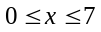
function [xmin,ymin,xmax,ymax]=extreme(first,last,num_steps,func)
msg=nargchk(4,4,nargin);
error(msg);
dx=(last-first)/(num_steps-1);
x=first:dx:last;
y=feval(func,x);
[ymax,maxy]=max(y);
[ymin,miny]=min(y);
xmax=x(maxy);
xmin=x(miny);
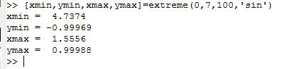

- Create a function of the following form:

result= area_or_volume(radius, height)

The function area_or_volume will return a result according to the number of input arguments. If the number of input arguments is two, it will return the volume of a cylinder by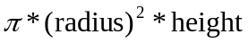. If the number of input arguments is one, it will return the area of a circle by 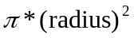.
For example,
>>result= area_or_volume(2, 3)
>>result =
37.6991
>>result= area_or_volume(2)
>>result =
12.5664
If the number of input arguments is illegal, it should output an error message.

function result=area_or_volume(radius,height)
msg=nargchk(1,2,nargin);
error(msg);
if nargin==1
height=1;
endif;
result=pi*(radius)^2*height;

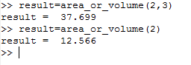

- Euler’s equation defines e raised to an imaginary power in terms of sinusoidal functions as follows:
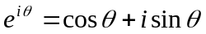
  - Create a two-dimensional plot of this function as θ varies from 0 to 2π.
t=0:0.1:2*pi;
s=cos(t)+i.*sin(t);
plot(s);
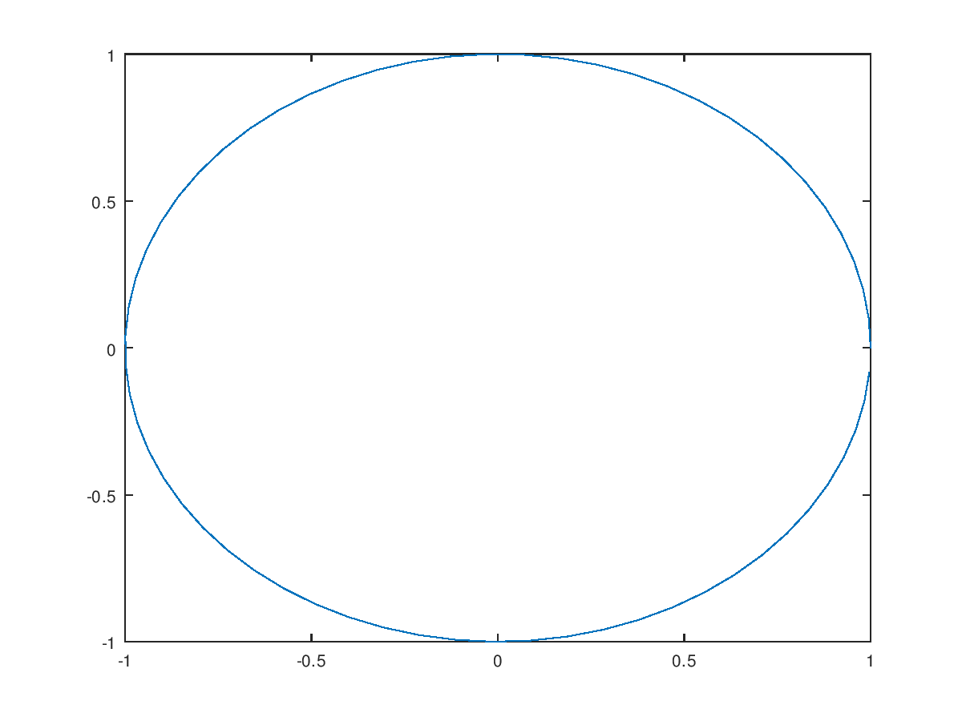
  - Create a three-dimensional line plot using function plot3 as θ varies from 0 to 2π (the three dimensions are the real part of the expression, the imaginary part of the expression, and θ.

clear all;
close all;
[x,y]=meshgrid(0:pi/20:2*pi);

%Calculate function
z=cos(x)+i.*sin(x);
figure(1);
mesh(x,y,real(z));
title('\bfMesh plot of real(\itz\rm\bf),where \it z=cos(x)+i.*sin(x)');
xlabel('\bfx');
ylabel('\bfy');
zlabel('\bfz');
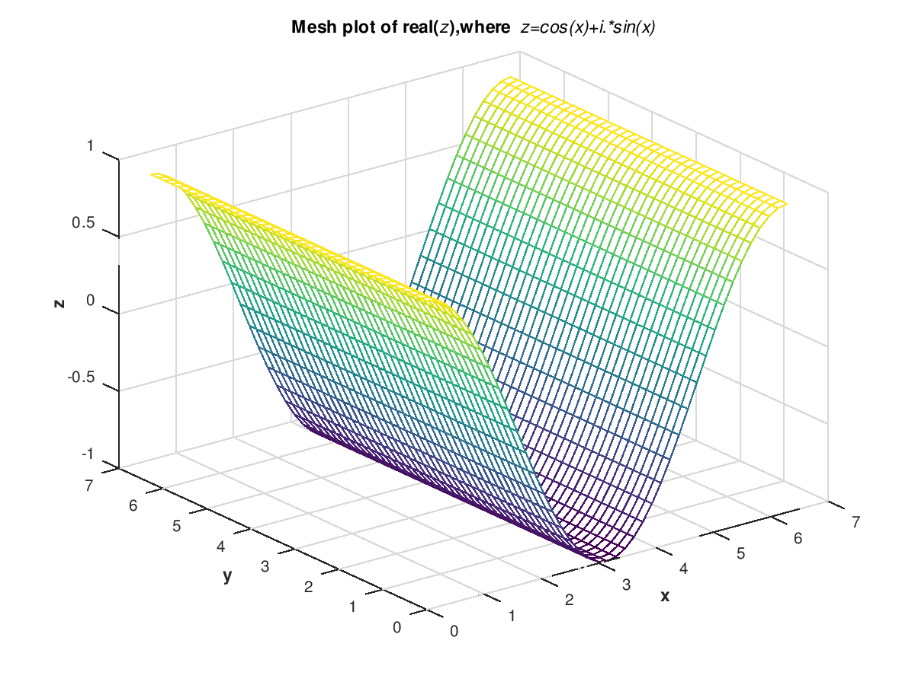
- Write a program that accepts an input string from the user and determines how many times a user-specified character appears within the string without regard to the case of the character.

clear all;
close all;

c=input('Enter a string:',"S");
d=input('Enter a character:',"S");
count=0;
for i=1:length(c);
if strncmpi(c(i),d,1)
count=count+1;
endif
endfor
printf('%d times\n',count);
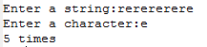

- Execute the following instructions to read an image data:
>> a=imread(‘girl.bmp’);
>>imshow(a);
As you can see in the workspace that the size of a is 256x256x3. a(: ,: ,1), a (: ,: ,2), and a(: ,: ,3 ) A, B, and C contain red, green, and blue components of this image, respectively. Please modify this image such that the intersection between rows 100 to 150 and columns 150 to 200 will appear in red color.
a=imread('girl.bmp');
a(150:200,100:150,1)=ones(51,51)*255; %在21*21範圍 %紅 1
a(150:200,100:150,2)=zeros(51,51); %綠 2
a(150:200,100:150,3)=zeros(51,51); %藍 3
imshow(a);

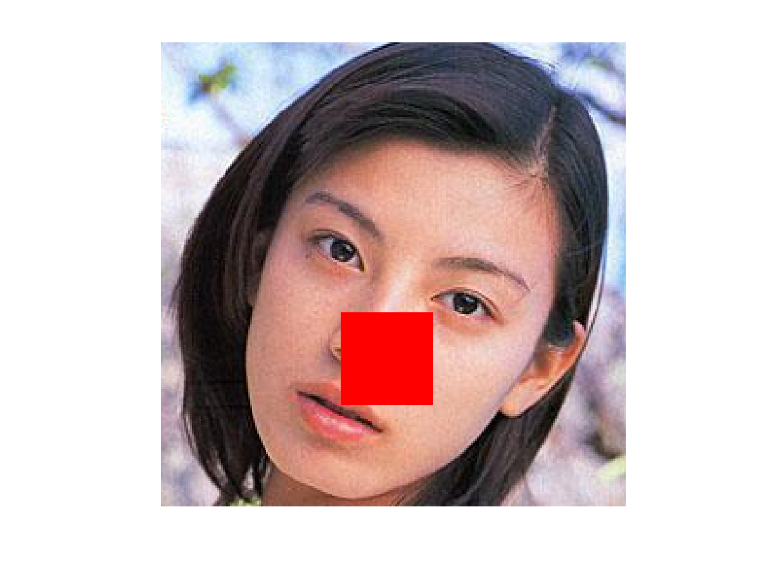

- (a) Creat a new function called caps( ) which capitalizes the first letter in each word and forces all other letters to be lower case.
function out=caps(str);
str=lower(str);
str(1)=upper(str(1));
n=length(str);
for i=2:n
if isspace(str(i-1))&isletter(str(i))
str(i)=upper(str(i));
end
end
out=str;
endfunction
(b) Test this function by the string “This is a test”.
